**ASSISTED PRACTICE (HTTP AUTHENTICATION MANAGER, COOKIES AND CSV DATA SET CONFIG)**

HTTP Authentication Manager :

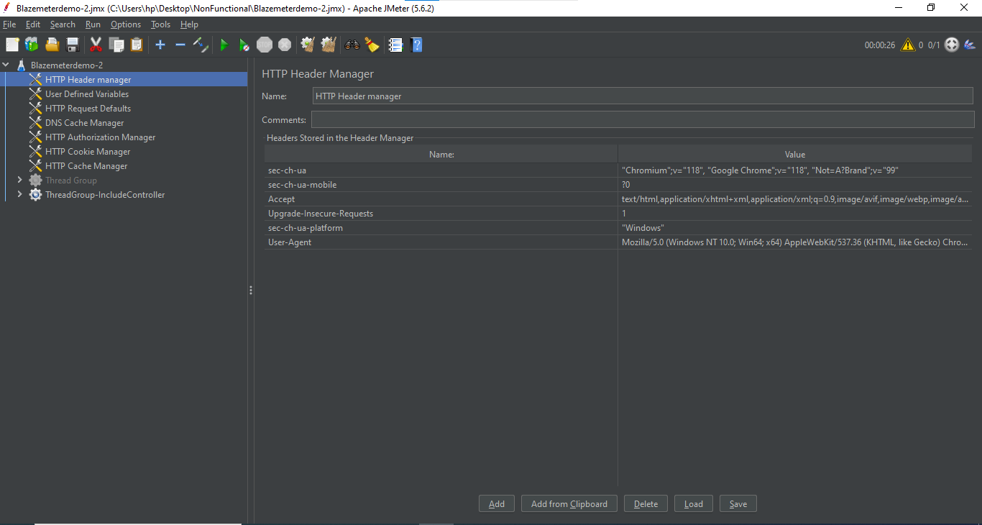

Cookies:

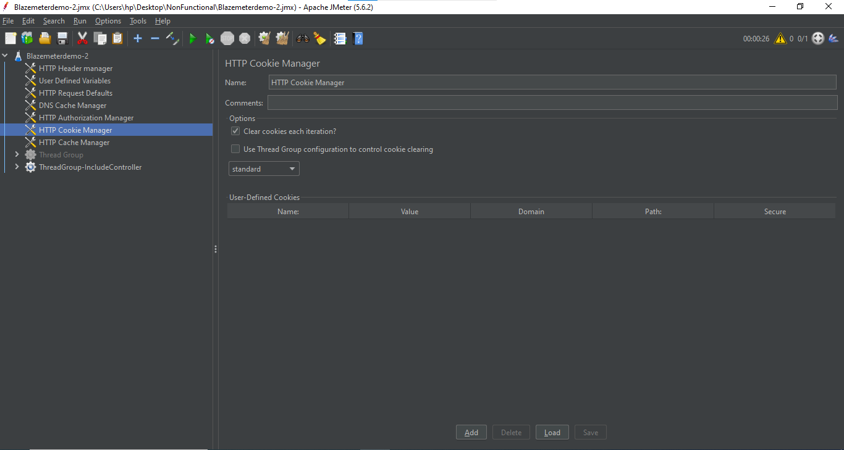

CSV Data Set Config:

Step1: For this, first make the excel file as shown below:

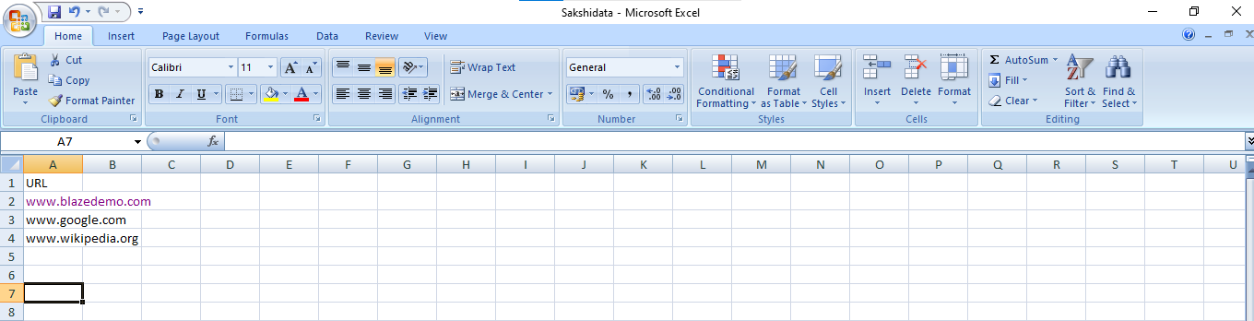

Step2: Save this excel file in Desktop folder

Step3: Open Jmeter -> Add Thread Group

Step4: Right click on Thread Group -> Add -> Logic controllers -> While controller

Step5: In While Controller, Give the details as shown below:

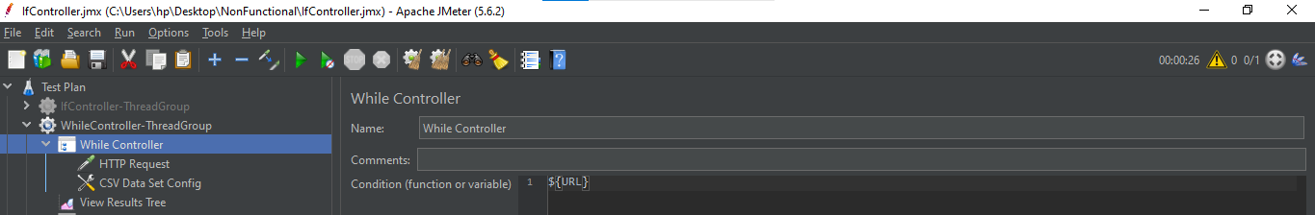

Step6: Right click on While controller -> Add -> Sampler -> HTTP Request

Step7: In HTTP Request, Give the details as shown below:

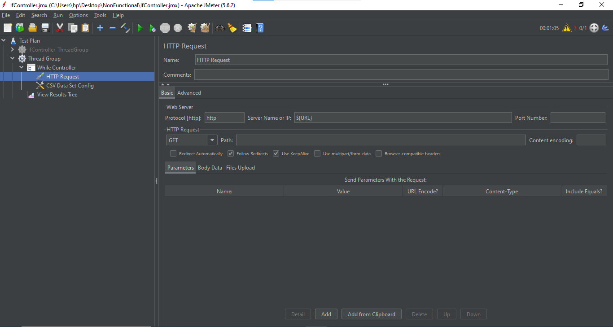

Step8: Right click on While controller -> Add -> Config Element -> CSV Data Set Config

Step9: In CSV Data Set Config , Give the details as shown below:

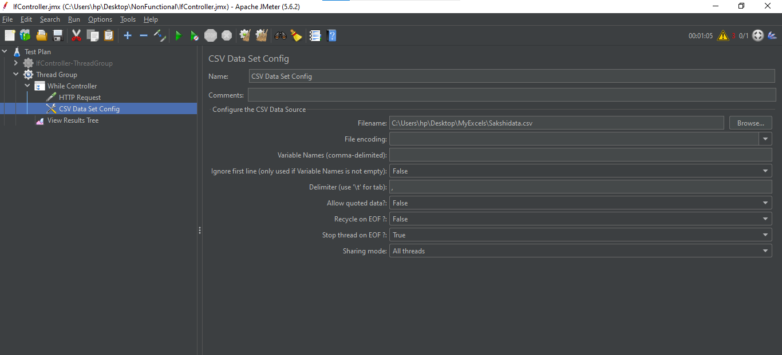

Step10: Right click on Thread Group -> Add -> Listener -> View Results Tree

Step11: Right click on Thread Group -> Add -> Listener -> Aggregate Report

View Results Tree:

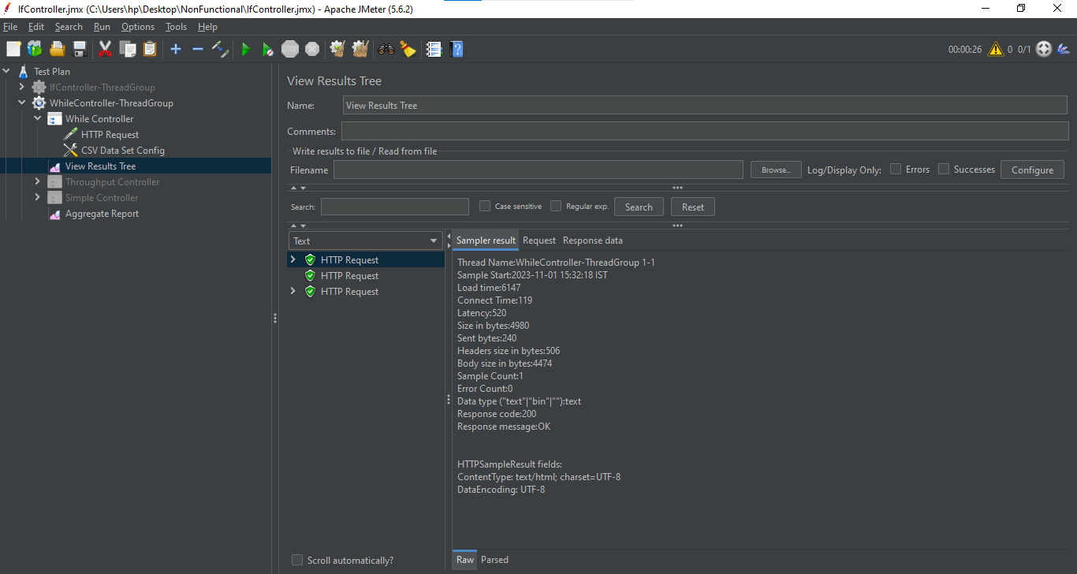

Aggregate Report:

